**MA RAQUEL SORIANO**

**HHA 507**

**SQL Database Foundations: Section 4**

**4-1: Using Oracle SQL Developer Data Modeler to Build ERDs**

Use Oracle SQL Developer Data Modeler to identify and create the:

− Entities for a School Management System

− Attributes for each of the Entities identified

− Relationship between the entities

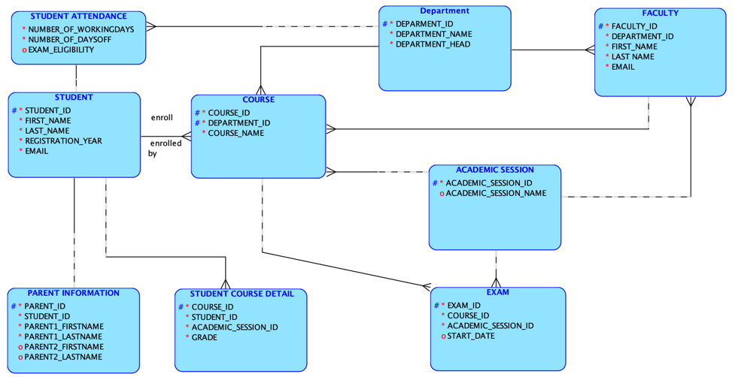

**4-2: Convert a Logical Model to a Relational Model Practices**

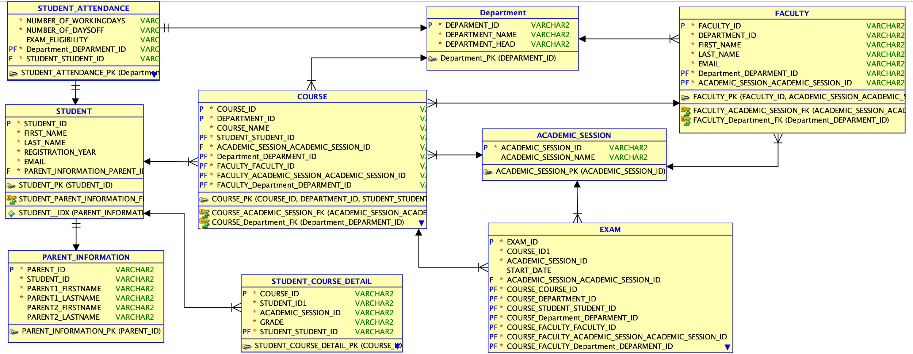

**SQL Database Foundations: Section 5-1**

**Exercise 1: Creating a Glossary from the Logical Model**

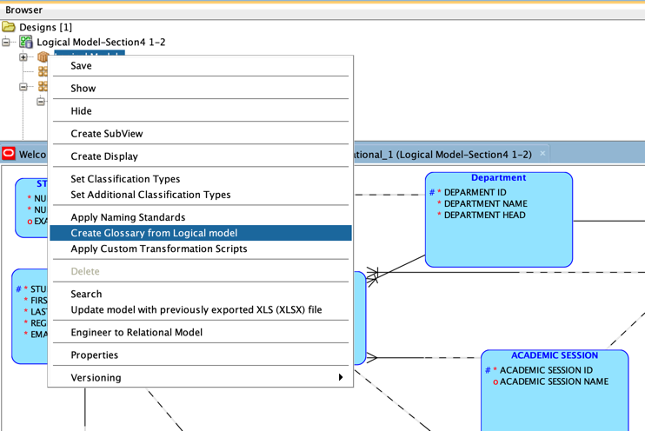

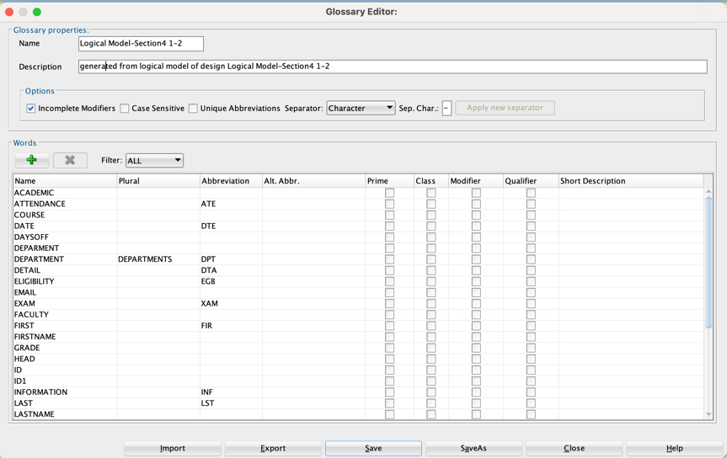

**Exercise 2: Forward engineering the design to apply the Glossary and Naming Standard**

1) a.

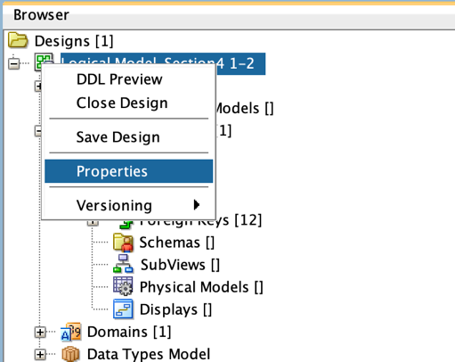

a. and b.

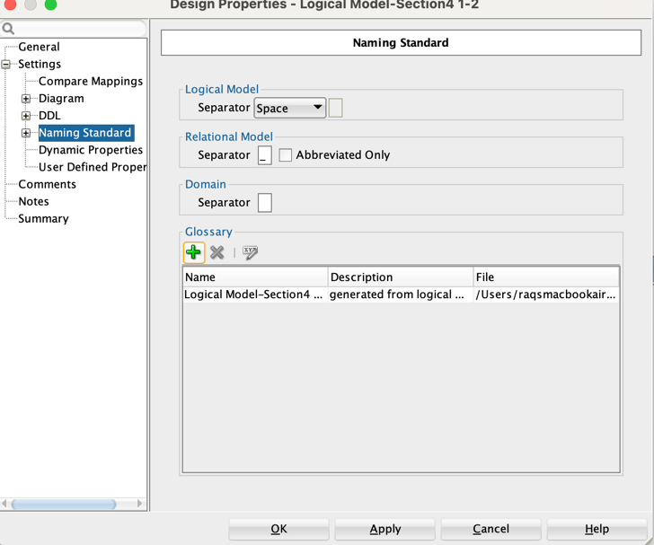

2) a.

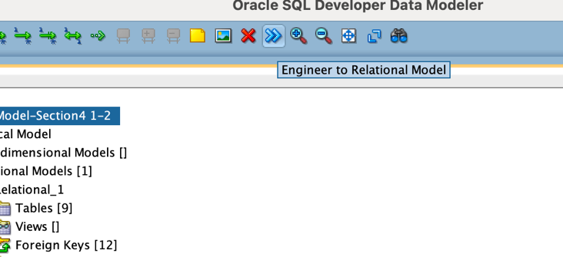

b.

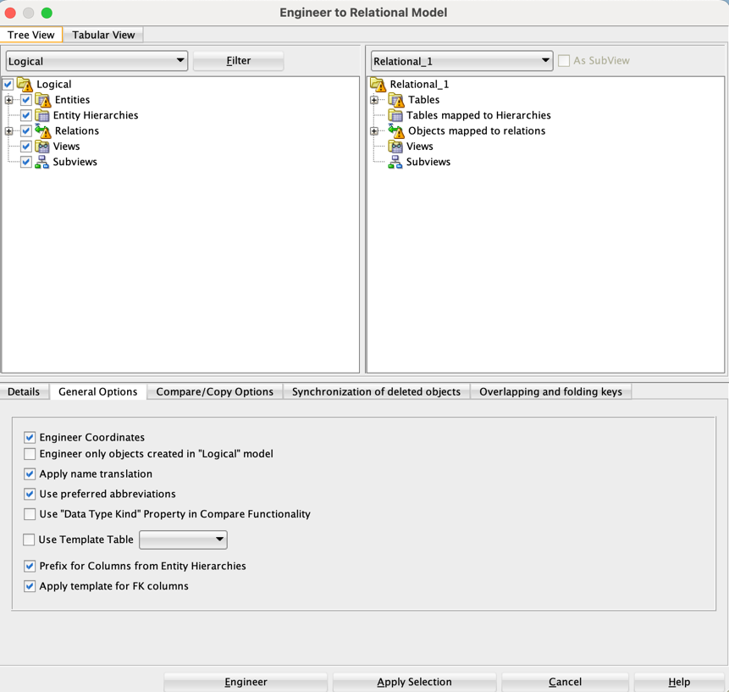

2) c.

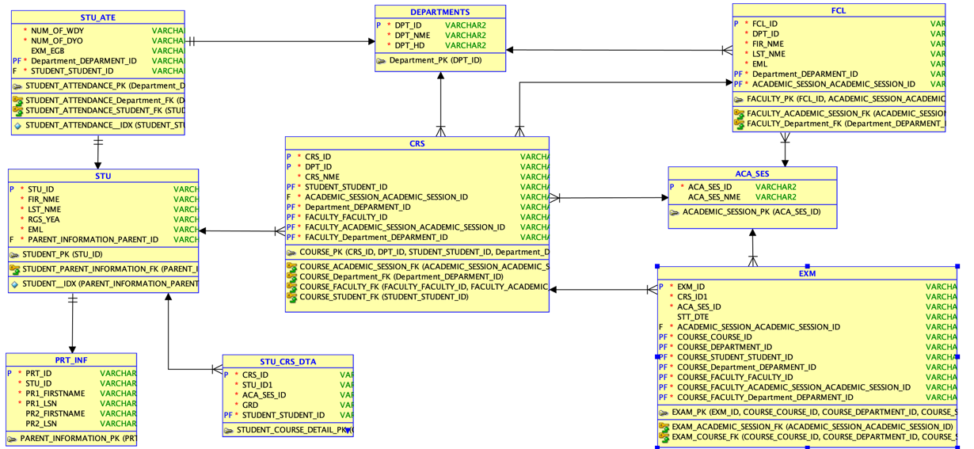

**SQL Database Foundations: Section 6-1 Introduction to Oracle Application Express**

I followed the instructions to complete this task. Inside the Oracle Apex, I navigated to the features mentioned in the guide and proceeded to the next section.

**SQL Database Foundations: Section 6-2 Structured Query Language Practices**

**Exercise 1: Using Help in Oracle Application Express**

Task 1 & 2: (Utilized the sample inside the Help button under the Quick SQL window)

a. Managing Database Objects with Object Browser

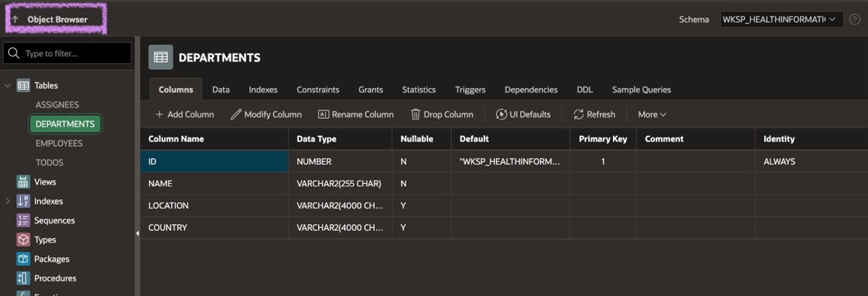

b. Using SQL Commands (Utilized the sample inside the Help button under the Quick SQL window)

c. Using SQL Scripts

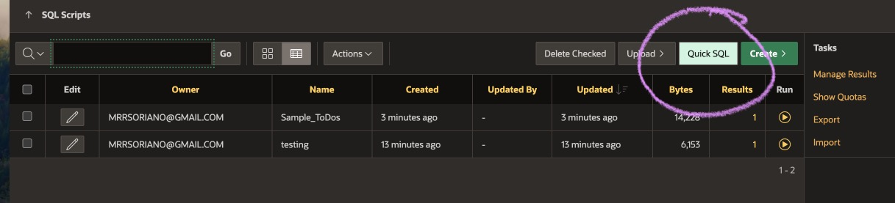

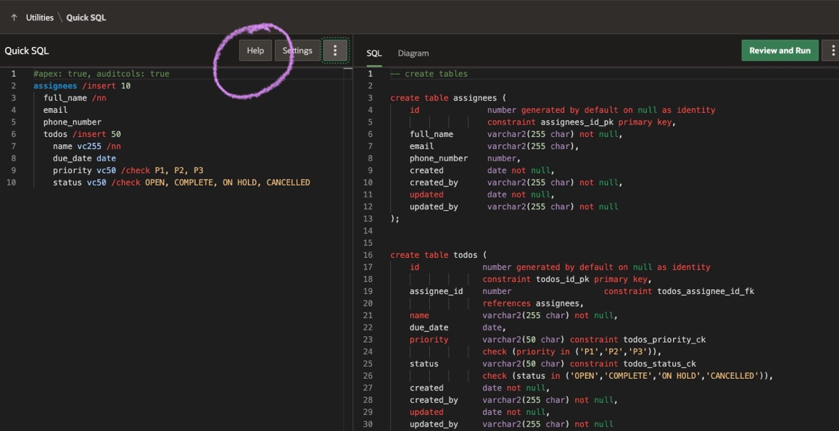

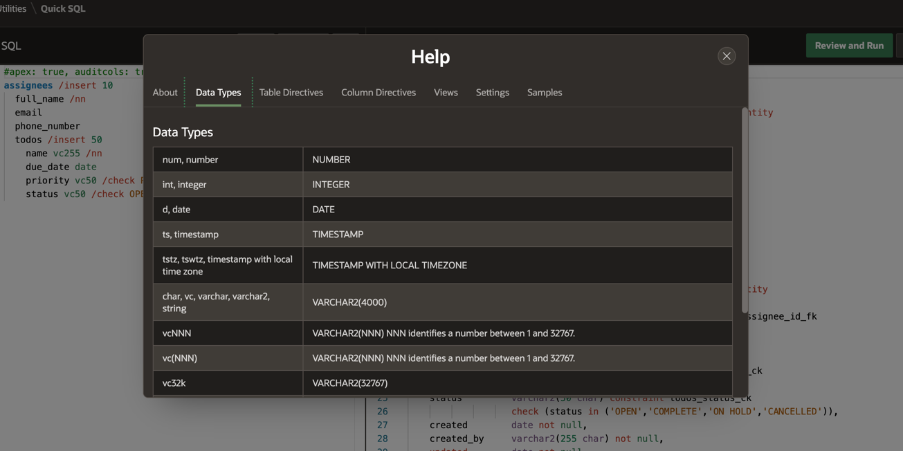

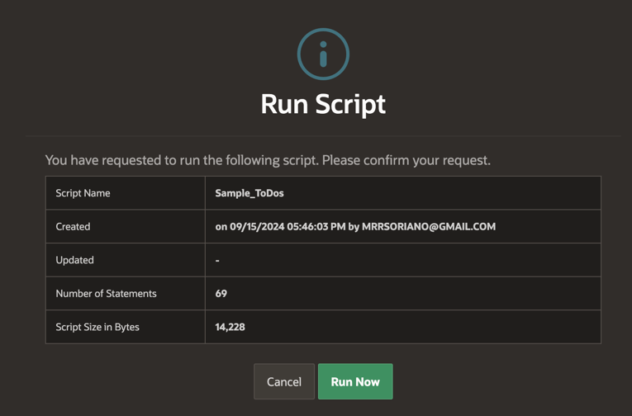

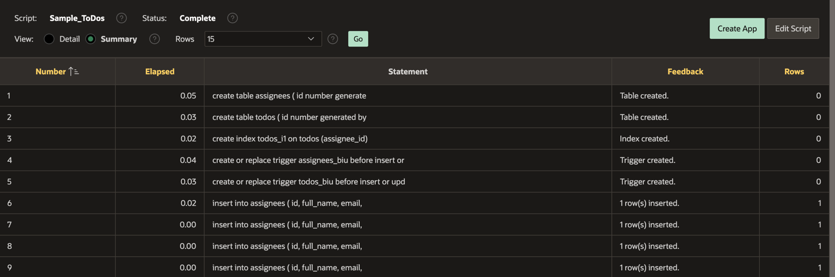

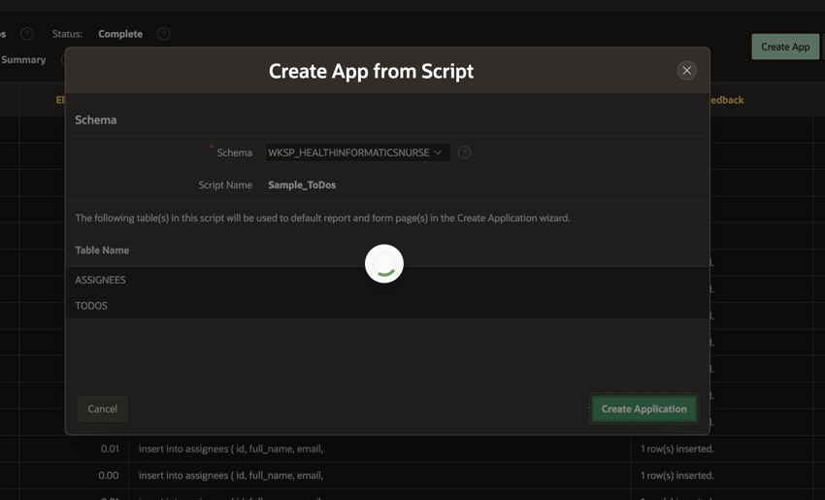

**SQL Database Foundations: Section 6-3 Defining Data Definition Language (DDL)**

**Exercise 1: Creating Tables Using Oracle Application Express**

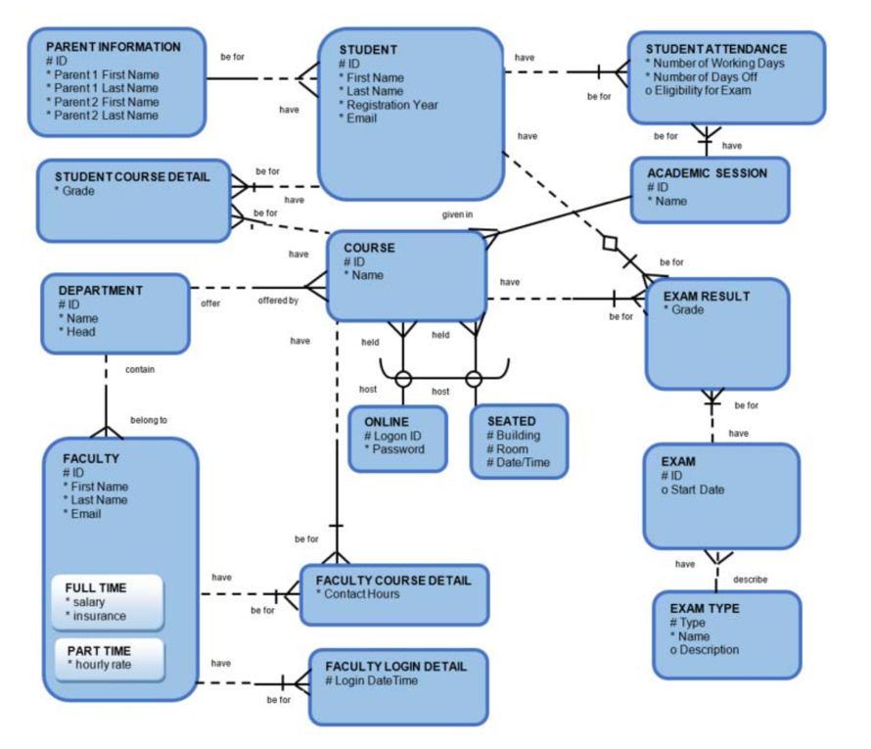

Task 1 and 2:

* Create the DDL Statements for creating the tables for the Academic Database listed on the ERD – include NOT NULL constraints where necessary. (Other constraints will be added later)
* Run/execute these commands in **Oracle Application Express**

Created tables (Student. Department, Faculty, Course etc.)

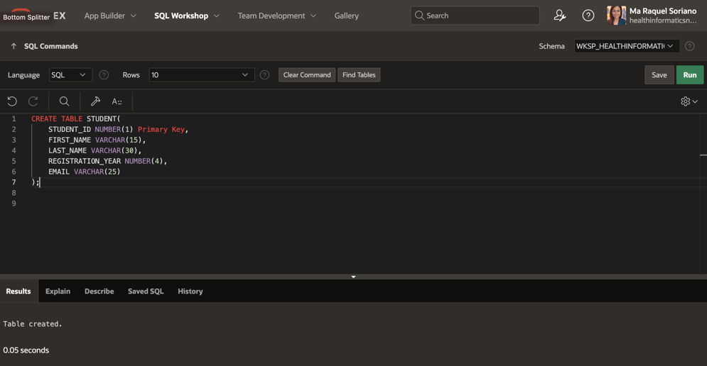

Inserted values for each attributes/entity. (See some of the samples I made)

*Note:* It took me almost half a day to figure out why I keep getting error messages.

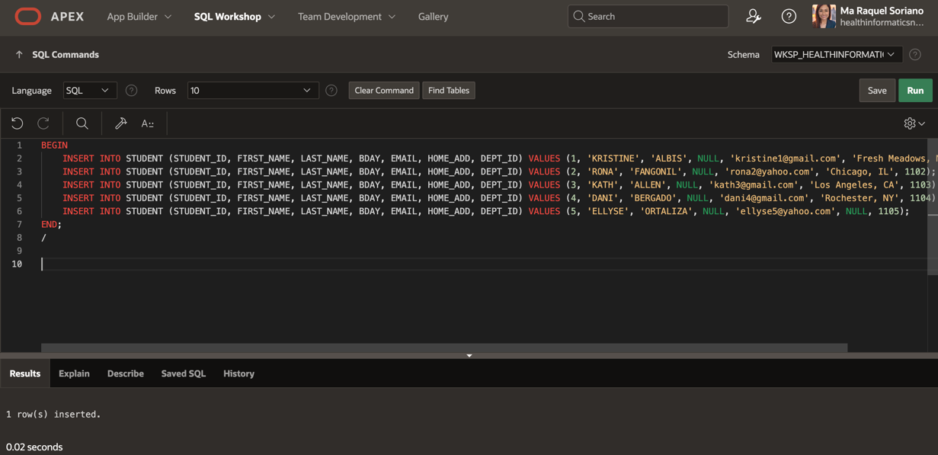

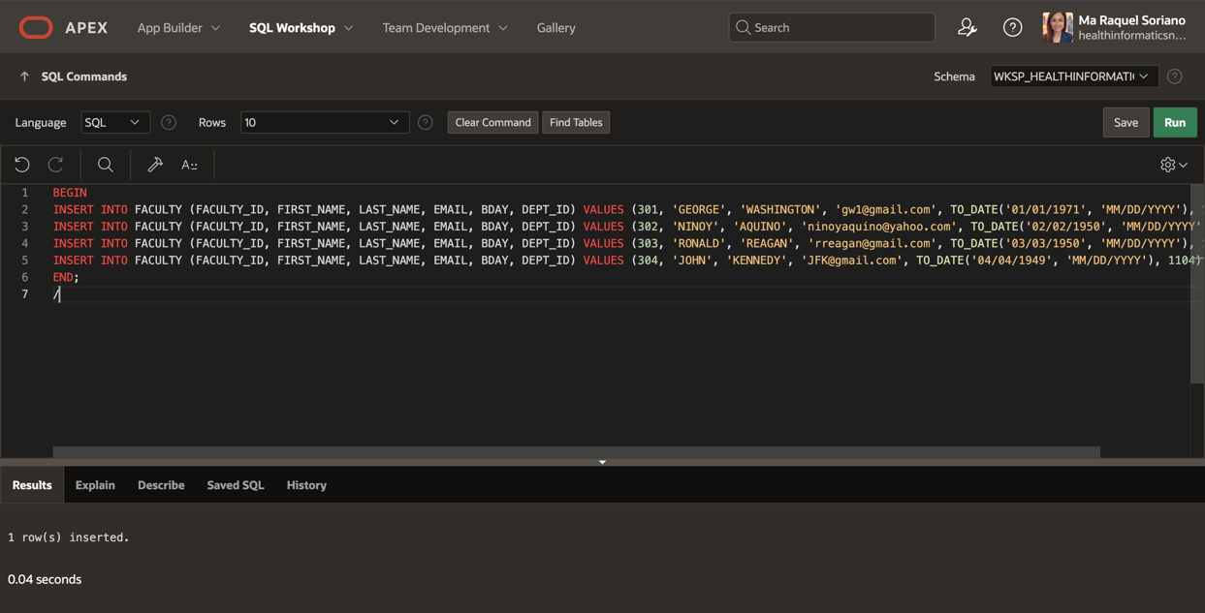

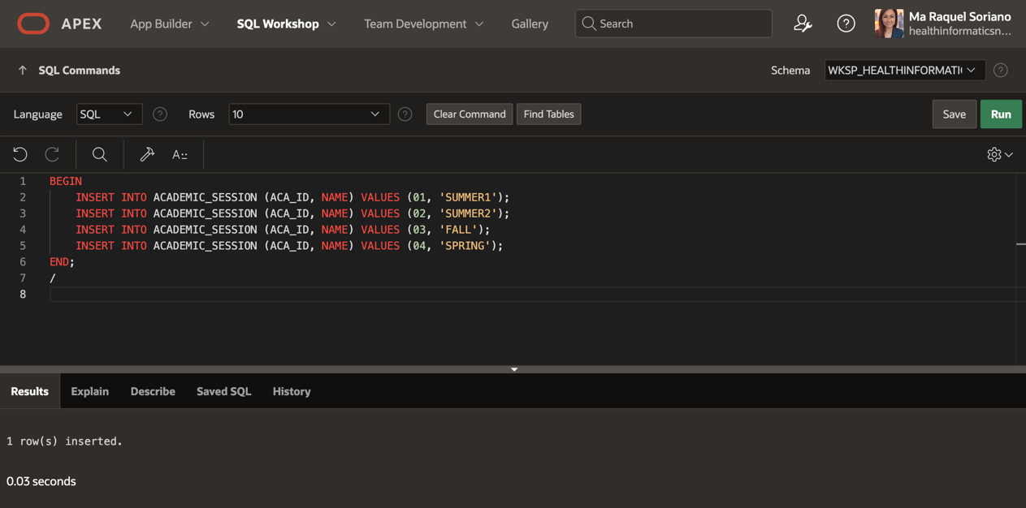

**Exercise 2: Altering the Tables**

**Assumptions**

The primary and foreign key constraints are based on the ERD shown in the previous exercise and the unique constraints are based on

the following :

The following fields should have unique values:

• Course Name in AD_COURSES

• Department Name in AD_DEPARTMENTS

• Student Email in AD_STUDENTS

• Faculty Email in AD_FACULTY

• Session Name in AD_ACADEMIC_SESSIONS

Task 1

1) Alter the tables in the Academic Database to define the primary key, foreign key and unique constraints.

*Note:* I have been trying to alter table, but I realized that I have assigned a primary key to each table. Therefore, it is not allowing me to alter each of them.

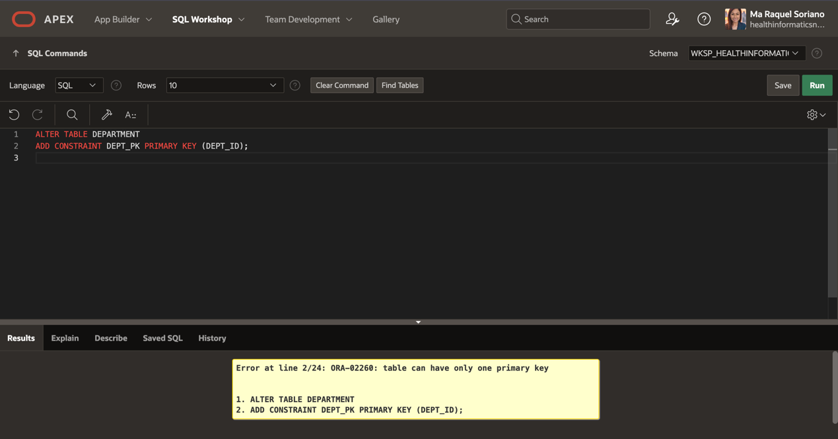

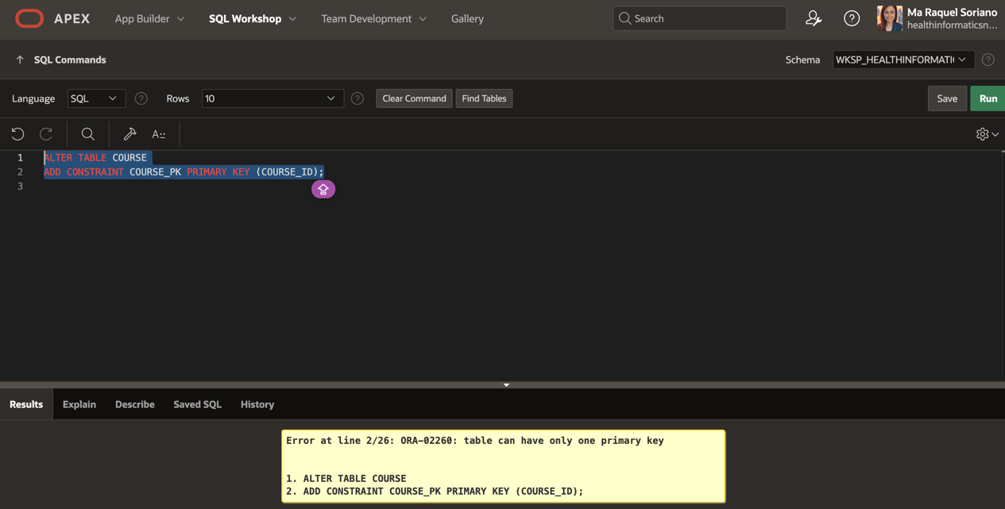

2) Alter the table AD_FACULTY_LOGIN_DETAILS and specify a default value for the column LOGIN_DATE_TIME of SYSDATE.

I initially encountered an error message because of the way I input the table name which is without the ‘AD’ so I removed that and I was able to successfully created and altered the table for FACULTY LOGIN DETAILS (see third photo below).

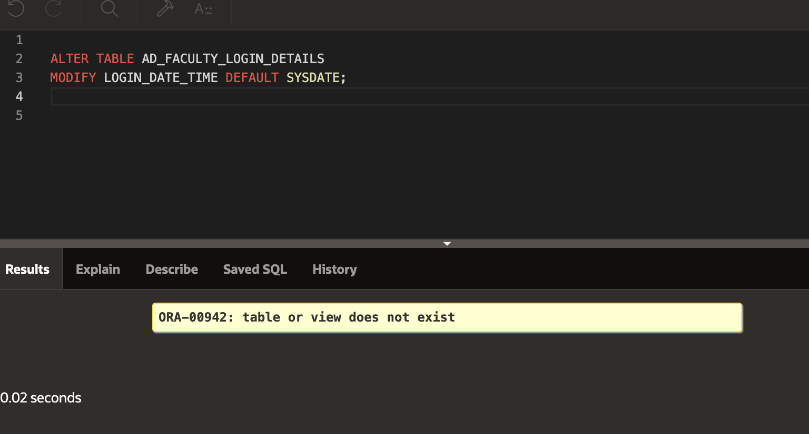

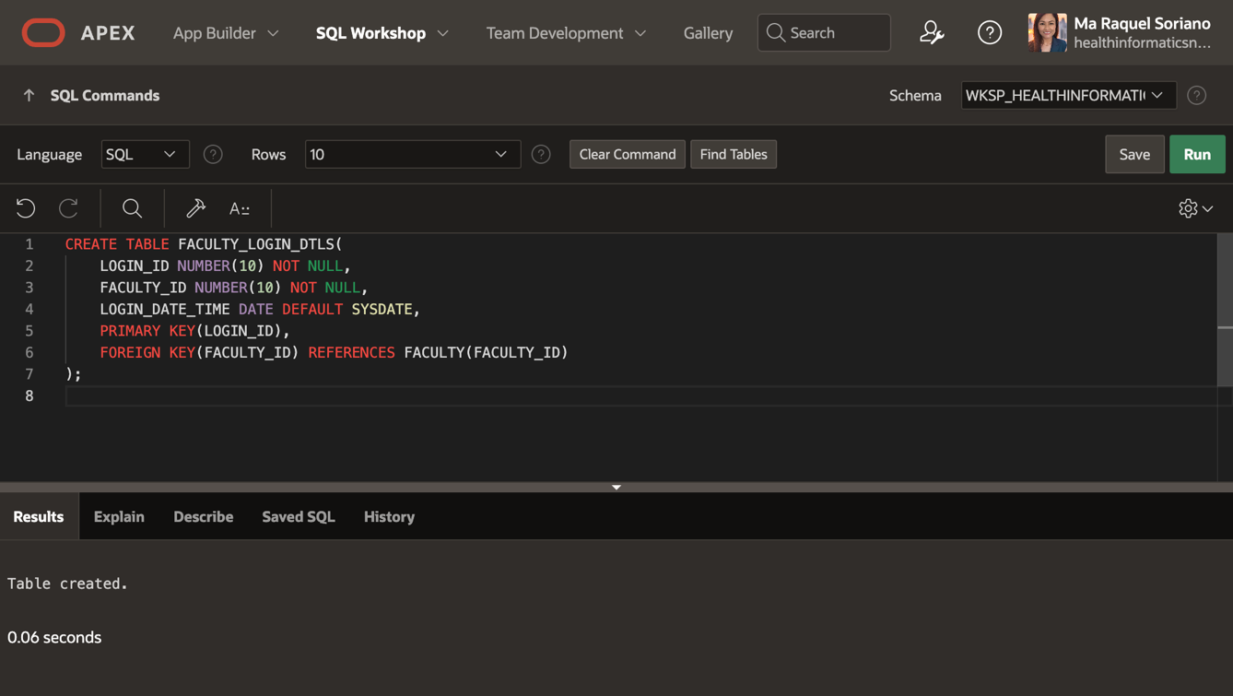

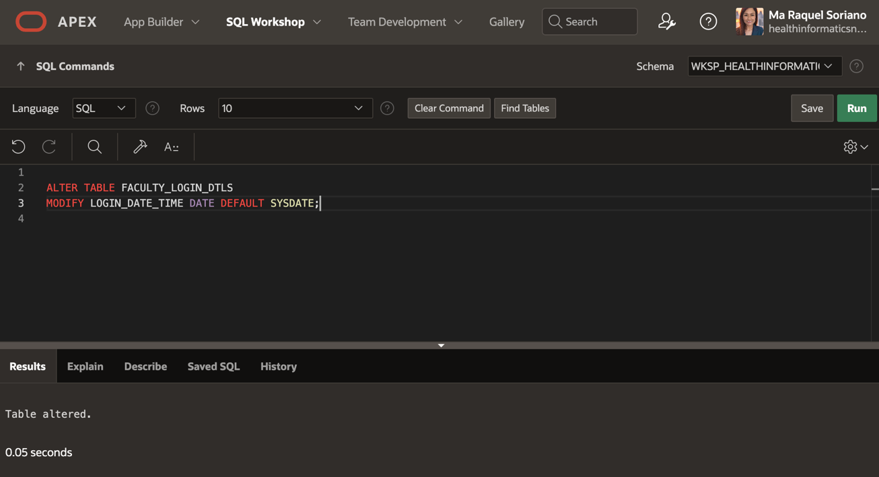

3) Set the AD_PARENT_INFORMATION table to a read-only status.

I ran into the same error message. However, by removing the word ‘AD’, I was able to alter the parent_information table.

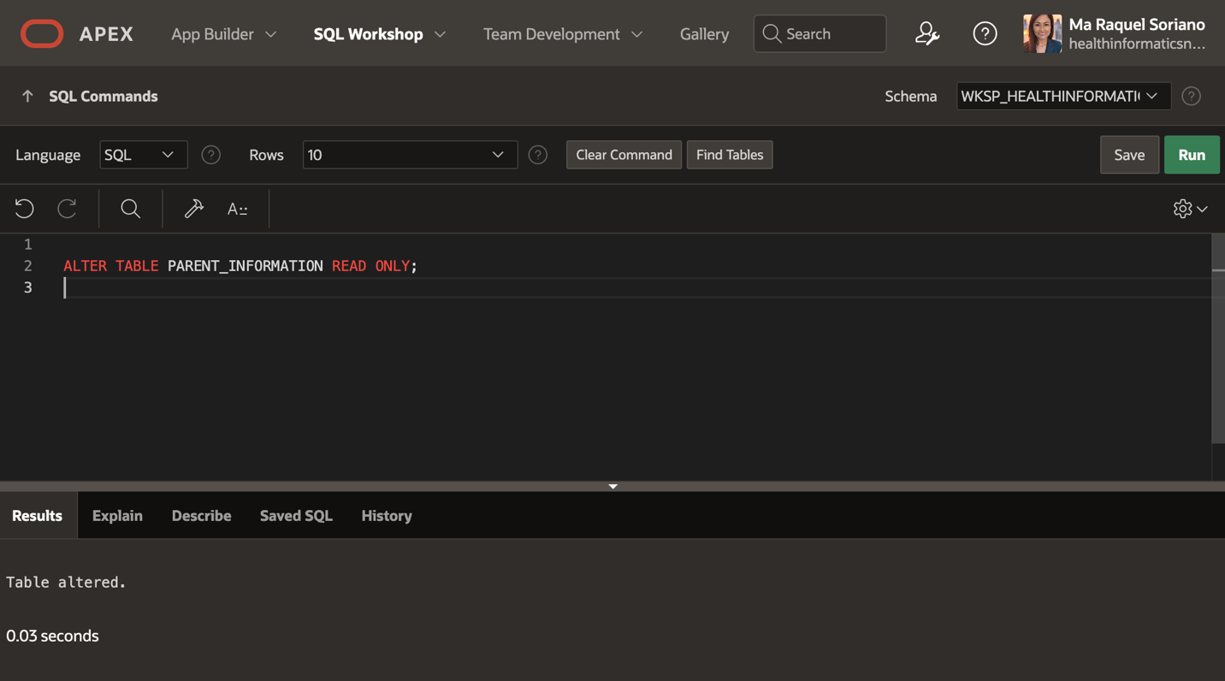

**Exercise 3: Creating Composite Primary, Foreign and Unique Keys**

Task 1

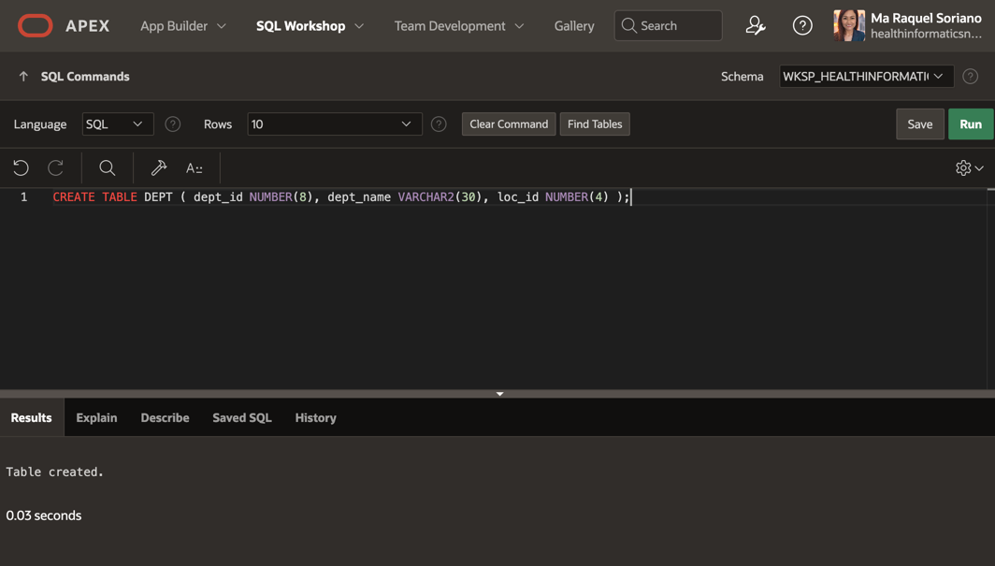

Task 2

SUPPLIERS TABLE

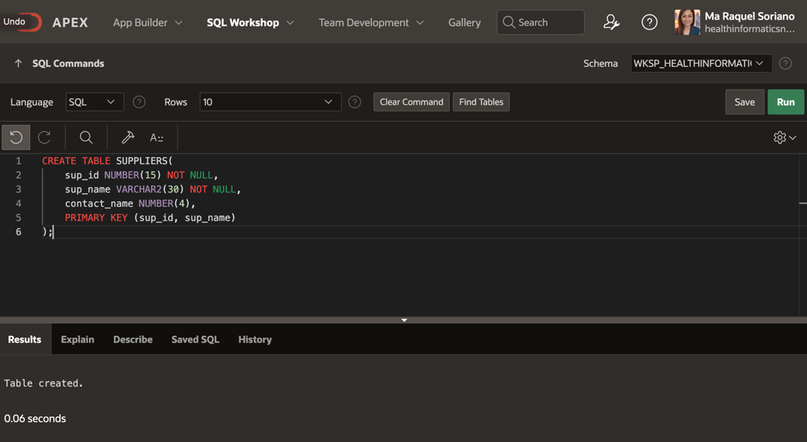

PRODUCTS TABLE

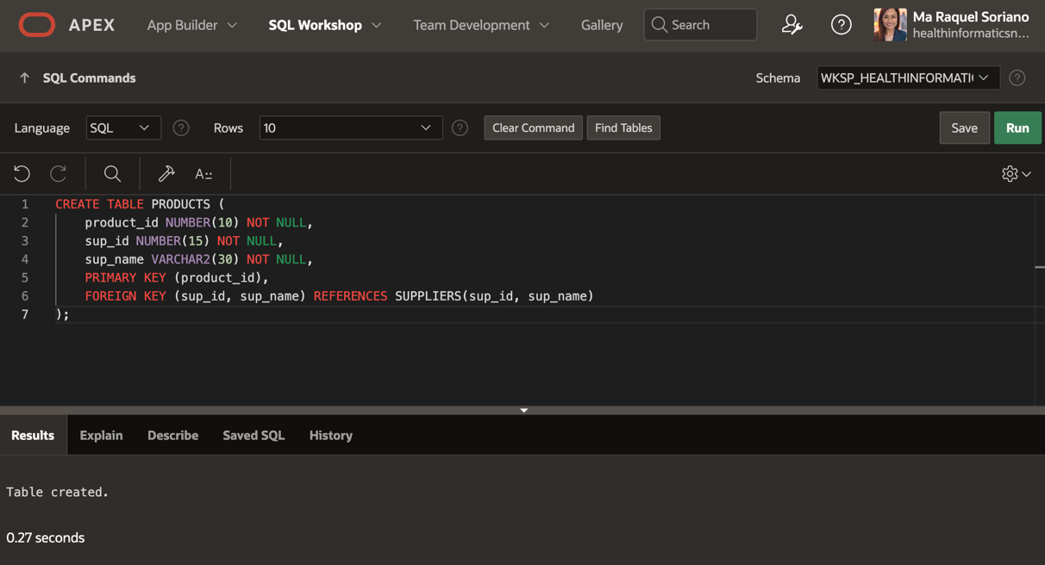

Task 3

Department Sample

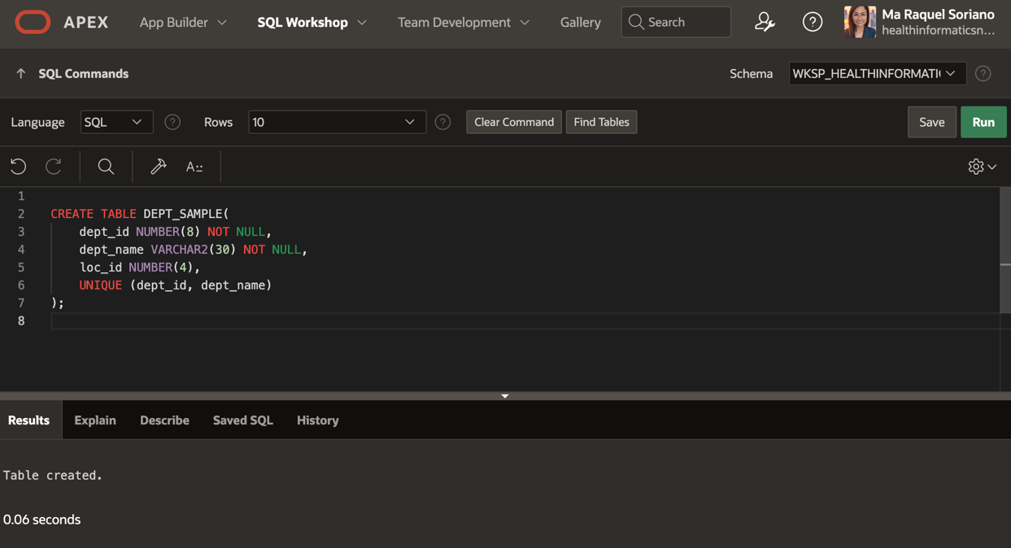

**SQL Database Foundations: Section 6-4 Defining Data Manipulation**

**Exercise 1: Inserting Rows in Tables**

Task 1

I ran into an error message while inserting rows into the AD_ACADEMIC_SESSIONS table. I realized that the reason this happened was due to a different table (name and its values) I initially created. I wanted to recreate the table to provide a correct answer for this exercise assignment, but I decided to just show the error message instead.

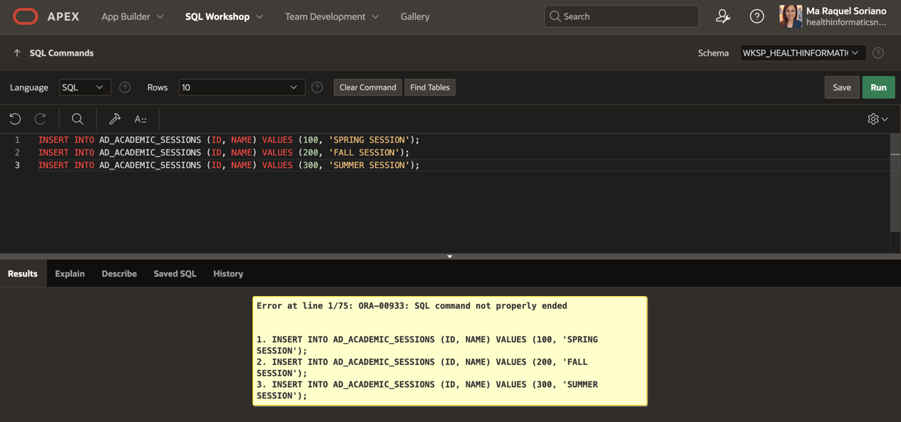

Task 2 and Task 3

Same error messages occurred when I attempted to insert rows into other tables for tasks 2 and 3 due to different table(s) and values I initially created. However, I just tried to include screenshots of the commands I used to insert rows.

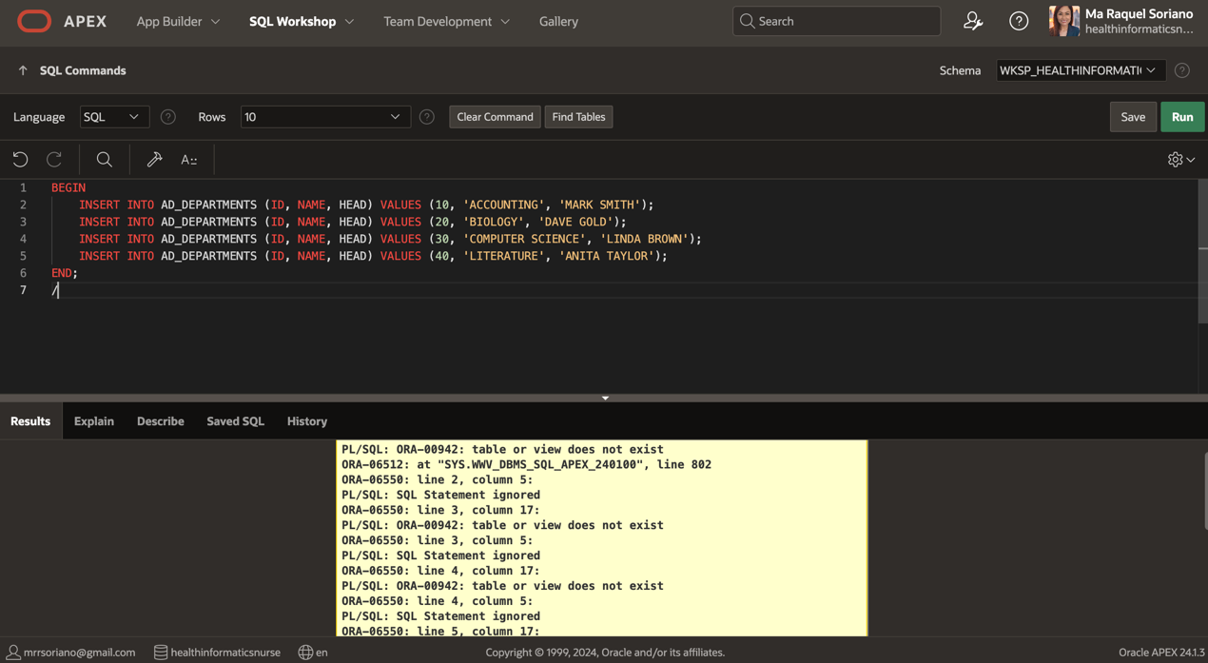

➢ AD_PARENT_INFORMATION

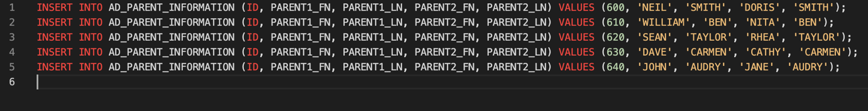

➢ AD_STUDENTS

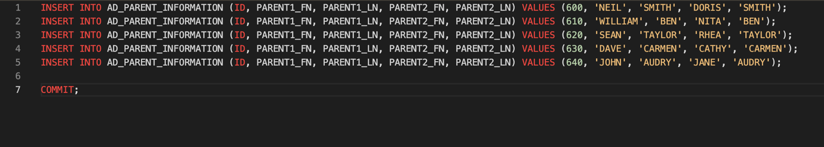

➢ AD_COURSES

INSERT INTO AD_COURSES (ID, NAME, SESSION_ID, DEPT_ID, LOGON_ID, PASSWORD, BUILDING, ROOM, DATE_TIME) VALUES (195, 'CELL BIOLOGY', 200, 20, NULL, NULL, 'BUILDING D', 401, 'MWF 9-10');

INSERT INTO AD_COURSES (ID, NAME, SESSION_ID, DEPT_ID, LOGON_ID, PASSWORD, BUILDING, ROOM, DATE_TIME) VALUES (190, 'PRINCIPLES OF ACCOUNTING', 100, 10, NULL, NULL, 'BUILDING A', 101, 'MWF 12-1');

INSERT INTO AD_COURSES (ID, NAME, SESSION_ID, DEPT_ID, LOGON_ID, PASSWORD, BUILDING, ROOM, DATE_TIME) VALUES (191, 'INTRODUCTION TO BUSINESS LAW', 100, 10, NULL, NULL, 'BUILDING B', 201, 'THUR 2-4');

INSERT INTO AD_COURSES (ID, NAME, SESSION_ID, DEPT_ID, LOGON_ID, PASSWORD, BUILDING, ROOM, DATE_TIME) VALUES (192, 'COST ACCOUNTING', 100, 10, NULL, NULL, 'BUILDING C', 301, 'TUES 5-7');

INSERT INTO AD_COURSES (ID, NAME, SESSION_ID, DEPT_ID, LOGON_ID, PASSWORD, BUILDING, ROOM, DATE_TIME) VALUES (193, 'STRATEGIC TAX PLANNING FOR BUSINESS', 100, 10, 'TAX123', 'PASSWORD', NULL, NULL, NULL);

INSERT INTO AD_COURSES (ID, NAME, SESSION_ID, DEPT_ID, LOGON_ID, PASSWORD, BUILDING, ROOM, DATE_TIME) VALUES (194, 'GENERAL BIOLOGY', 200, 20, 'BIO123', 'PASSWORD', NULL, NULL, NULL);

COMMIT;

➢ AD_COURSES

INSERT INTO AD_FACULTY (ID, FIRST_NAME, LAST_NAME, EMAIL, SALARY, INSURANCE, HOURLY_RATE, DEPT_ID) VALUES (800, 'JILL', 'MILLER', 'JMILL@SCHOOL.EDU', 10000, 'HEALTH', NULL, 20);

INSERT INTO AD_FACULTY (ID, FIRST_NAME, LAST_NAME, EMAIL, SALARY, INSURANCE, HOURLY_RATE, DEPT_ID) VALUES (810, 'JAMES', 'BORG', 'JBORG@SCHOOL.EDU', 30000, 'HEALTH,DENTAL', NULL, 10);

INSERT INTO AD_FACULTY (ID, FIRST_NAME, LAST_NAME, EMAIL, SALARY, INSURANCE, HOURLY_RATE, DEPT_ID) VALUES (820, 'LYNN', 'BROWN', 'LBROWN@SCHOOL.EDU', NULL, NULL, 50, 30);

INSERT INTO AD_FACULTY (ID, FIRST_NAME, LAST_NAME, EMAIL, SALARY, INSURANCE, HOURLY_RATE, DEPT_ID) VALUES (830, 'ARTHUR', 'SMITH', 'ASMITH@SCHOOL.EDU', NULL, NULL, 40, 10);

INSERT INTO AD_FACULTY (ID, FIRST_NAME, LAST_NAME, EMAIL, SALARY, INSURANCE, HOURLY_RATE, DEPT_ID) VALUES (840, 'SALLY', 'JONES', 'SJONES@SCHOOL.EDU', 50000, 'HEALTH,DENTAL,VISION', NULL, 40);

COMMIT;

➢ AD_EXAM_TYPES

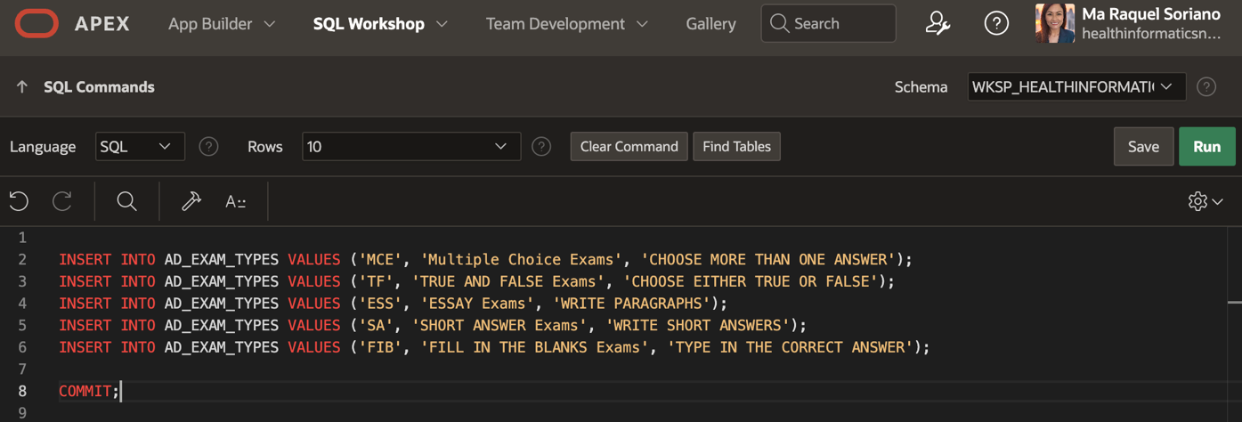

➢ AD_EXAM

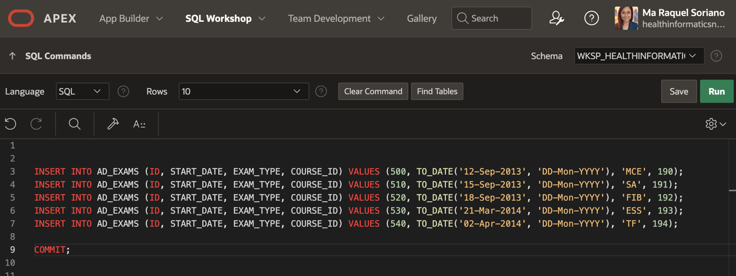

➢ AD_EXAM_RESULTS

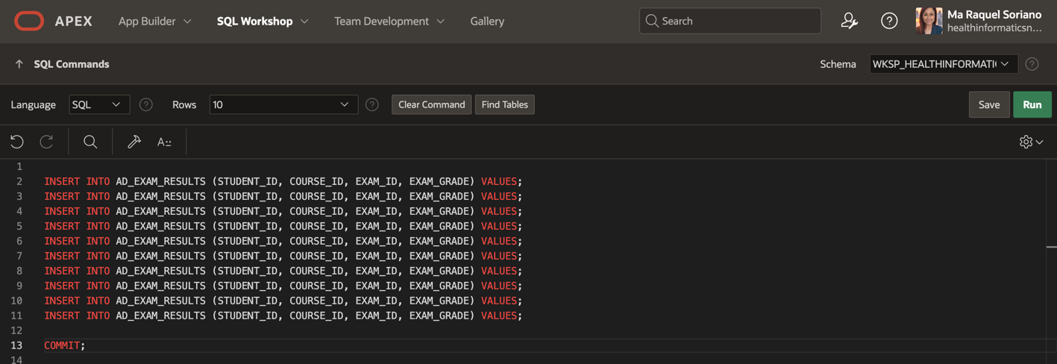

➢ AD_STUDENT_ATTENDANCE

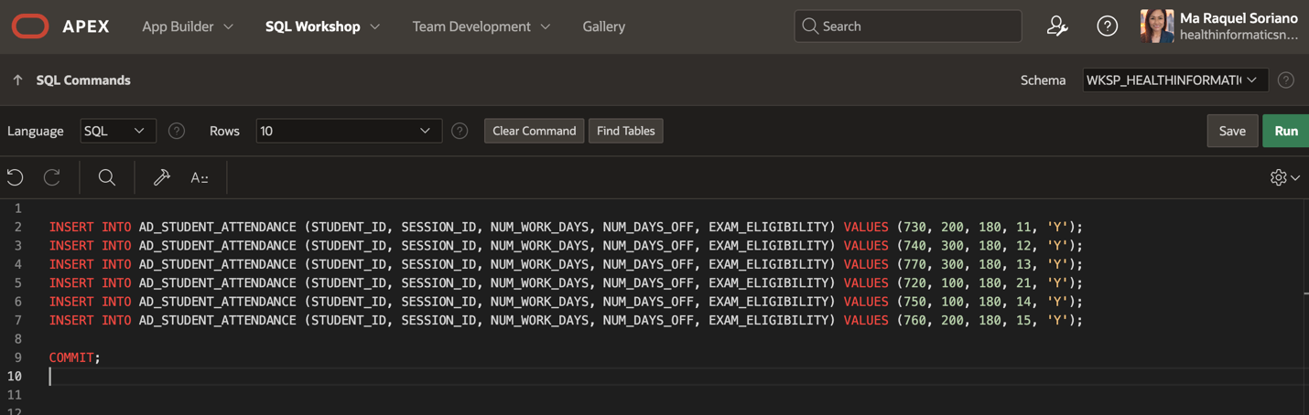

➢ AD_STUDENT_COURSE_DETAILS

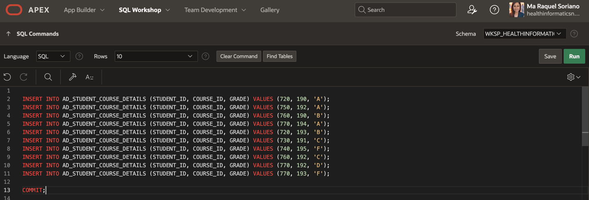

➢ AD_FACULTY_COURSE_DETAILS

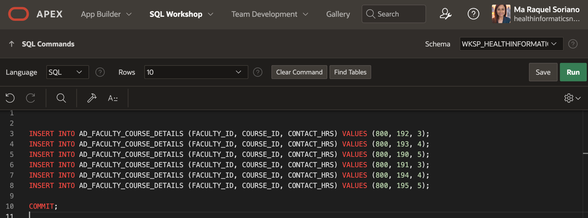

➢ AD_FACULTY_LOGIN_DETAILS

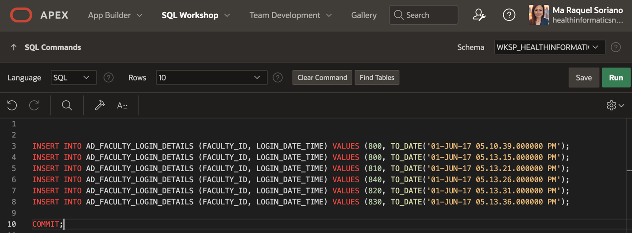

**Exercise 2: Updating Rows in the Tables**

Task 1 and 2:

Unable to complete exercise 2 due to the unsuccessful insertion of rows in the AD_FACULTY_LOGIN_DETAILS.

**SQL Database Foundations: Section 6-5 Defining Transaction Control**

**Exercise 1: Controlling Transactions**

Task 1 Answer ➙ **Yes**

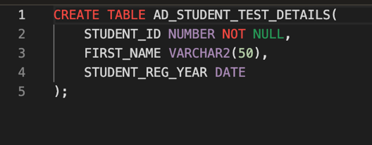

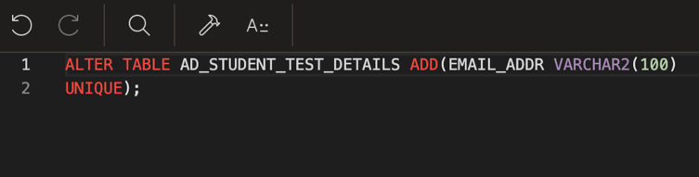

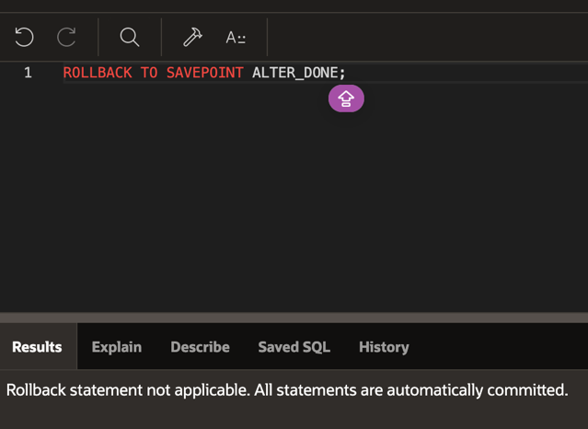

Task 2

I was unable to accomplish task 2 due to error messages. I checked multiple times for any misspelled words or punctuation, but it was still unsuccessful.

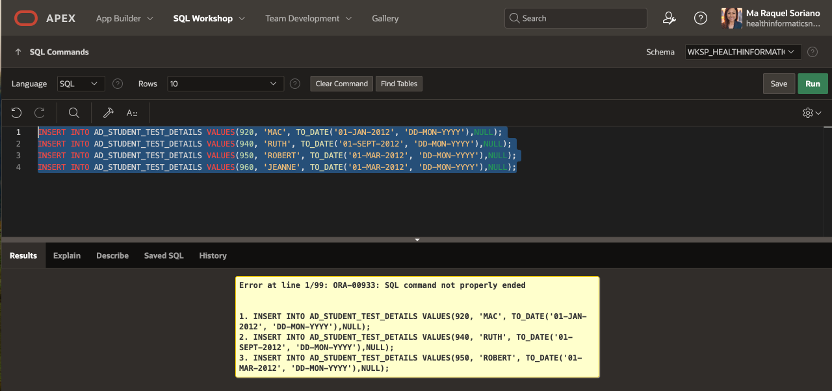

**SQL Database Foundations: Section 6-6 Retrieving Data**

**Exercise 1: Retrieving Columns from tables**

Task 1: Write a simple query to view the data inserted in the tables created for the academic database

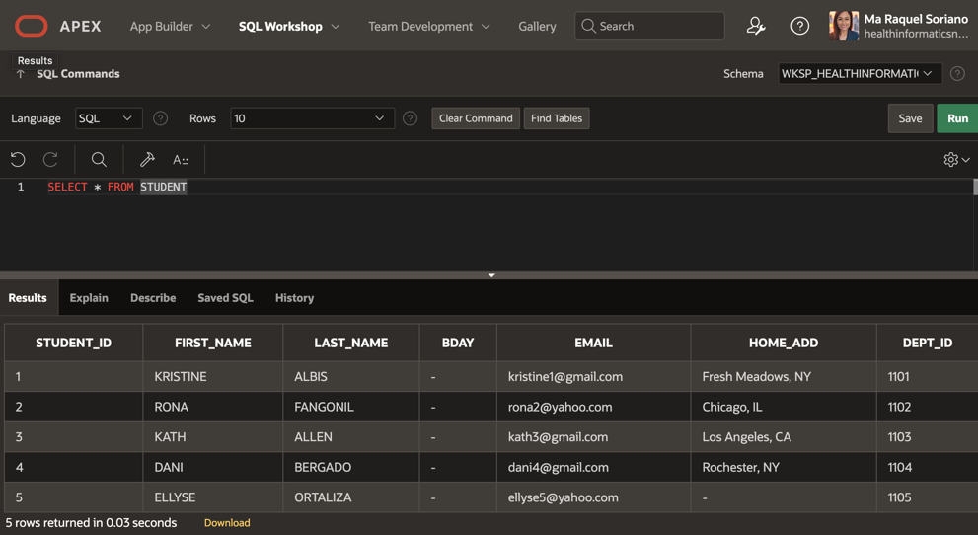

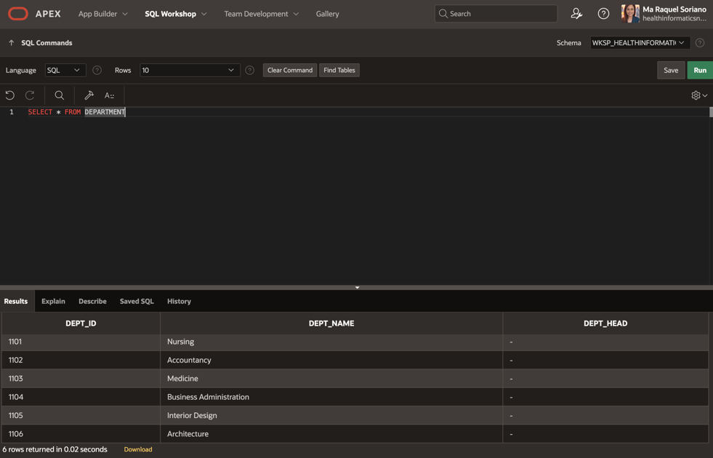

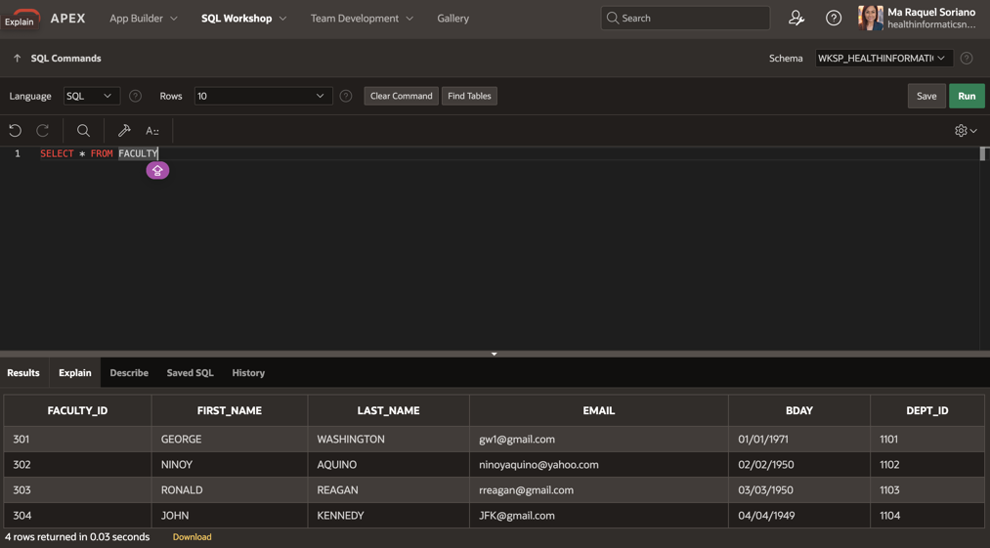

Task 2: Write a query to retrieve the exam grade obtained by each student for every exam attempted.

Initially, I was not able to create the EXAM_RESULTS table, so I couldn’t retrieve the exam grades. Therefore, I created a table and inserted values for student_ID, exam_ID, and exam_results (see photos below). Although, the student_ID column is still not showing the values even though I created and inserted values successfully.

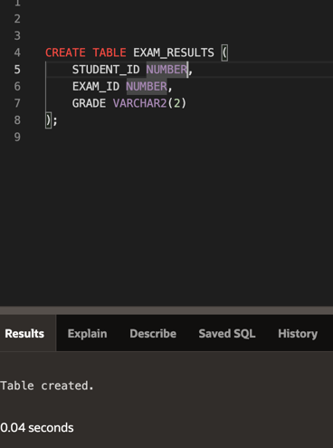

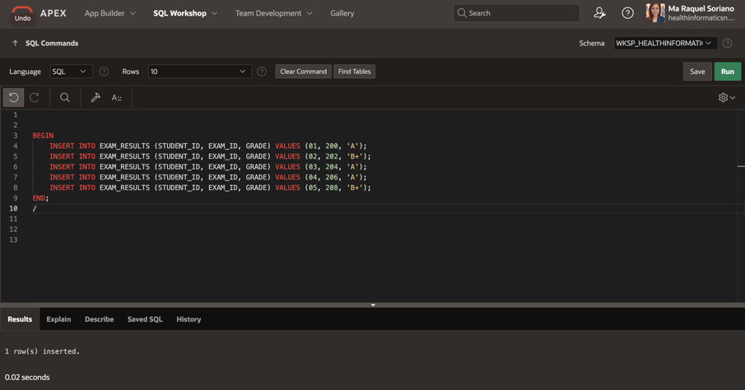

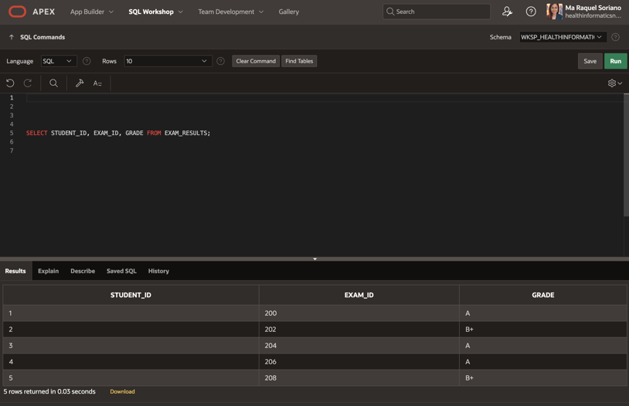

Task 3: Write a query to check if a student is eligible to take exams based on the number of days he/she attended classes.

Like in the previous task, I was unable to create the STUDENT_ATTENDANCE table. I tried to create one, but I kept getting error messages.

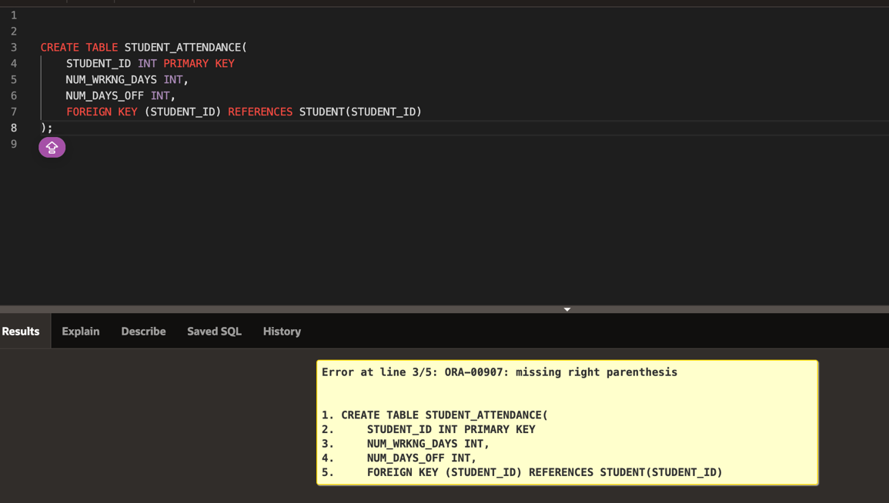

Task 4: Display the LOGIN_DATE_TIME for each faculty member.

The previous FACULTY_LOGIN_DETAILS I created doesn’t show up. Therefore, I re-created a new table. It took me hours before I got the second screenshot (inserted values). The reason for the error messages was a misspelled word ‘LOGID_ID’ instead of ‘LOGIN_ID’. I successfully inserted values once it has been corrected.

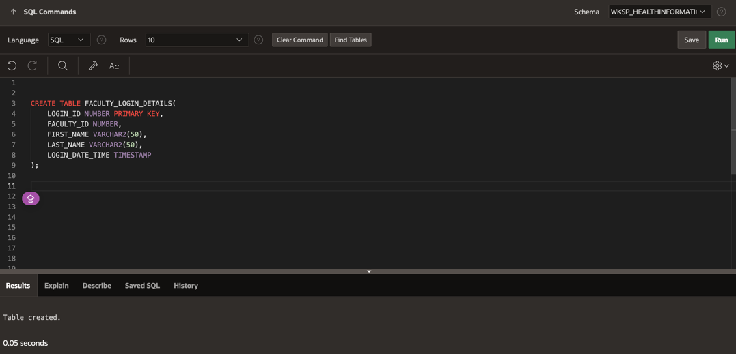

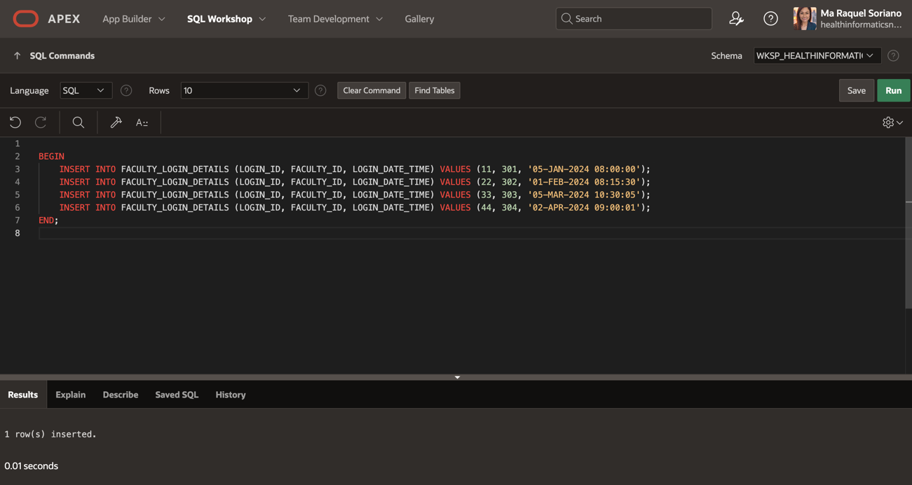

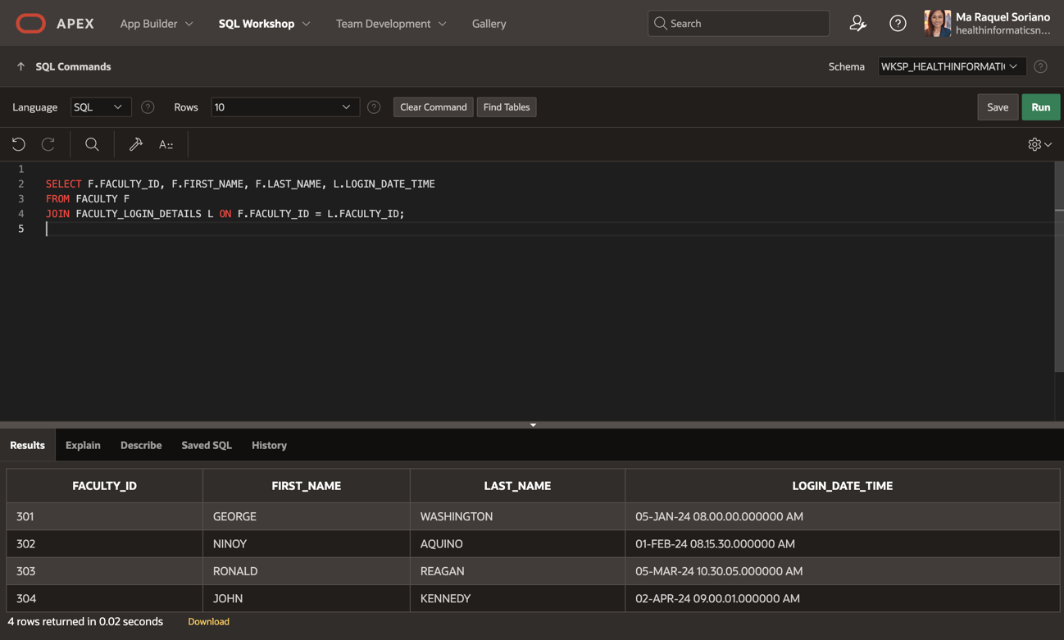

Task 5: Display the name of the Head of the Department for each of the Departments.

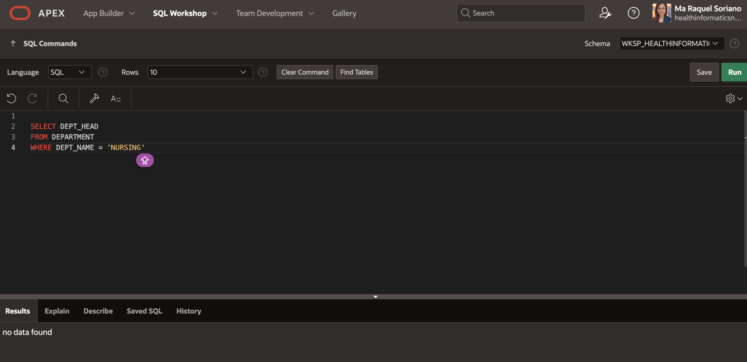

Task 6:

Retrieve the student ID and first name for each student concatenated with literal text to look like this:

720: FIRST NAME IS JACK

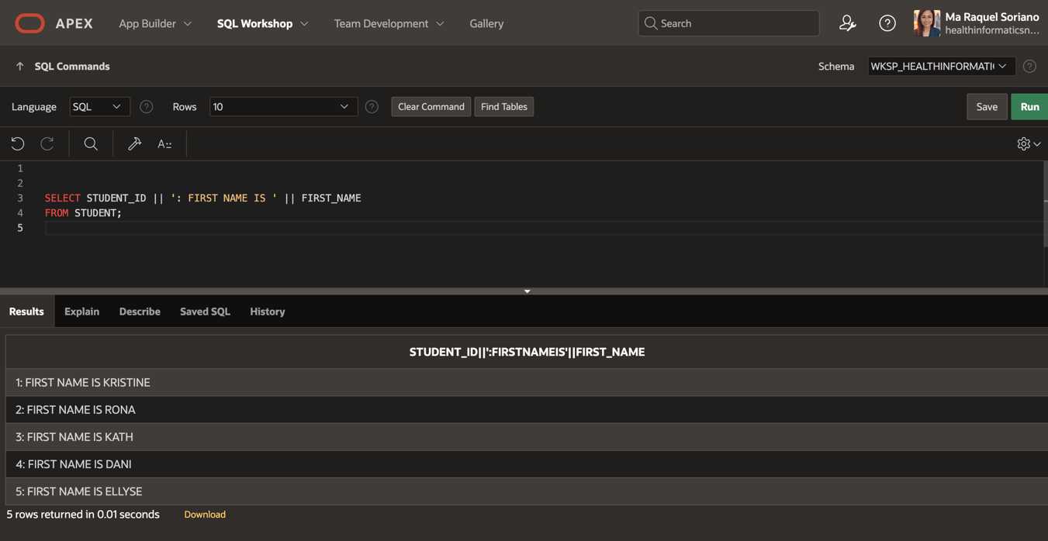

Task 7: Display all the distinct exam types from the AD_EXAMS table.

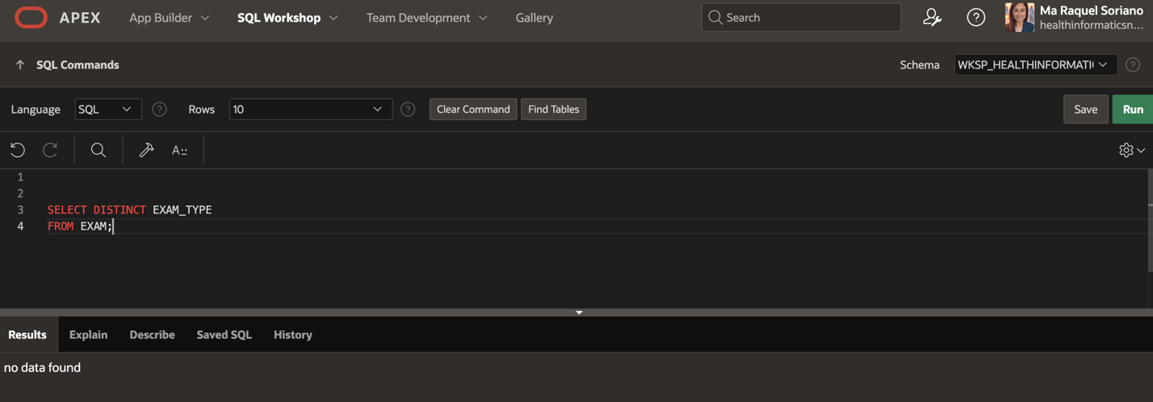

**SQL Database Foundations: Section 6-7 Restricting Data Using WHERE Statement**

**Exercise 1: Restricting Data Using SELECT**

Task 1: Display the course details for the Spring Session.

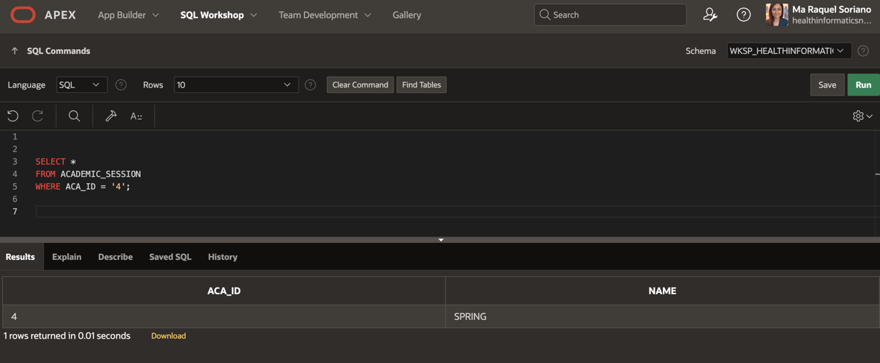

Task 2: Display the details of the students who have scored more than 95.

I encountered an error message, possibly due to a non-existent column (SCORE) in the STUDENT or EXAM/EXAM RESULT table.

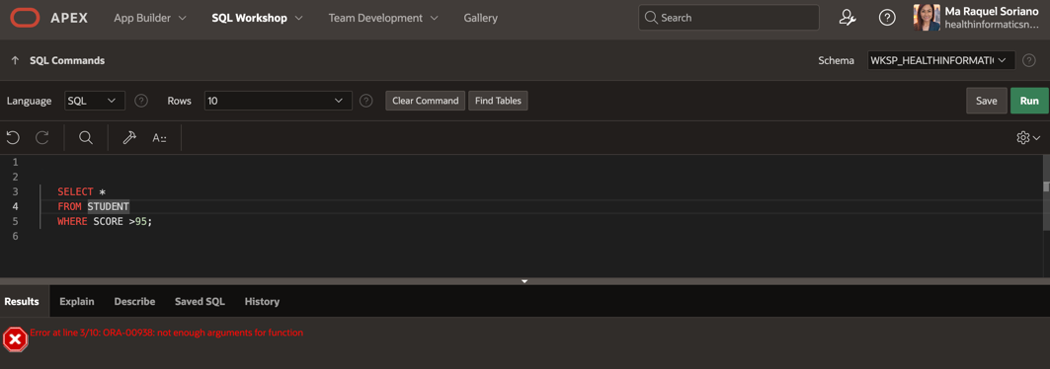

Task 3: Display the details of the students who have scored between 65 and 70.

Unable to accomplish this task due to a non-existent SCORE column in my table(s).

Task 4: Display the students who registered after 01-Jun-2012.

I inserted values for registration to a particular table to be able to generate registration dates as needed in this task.

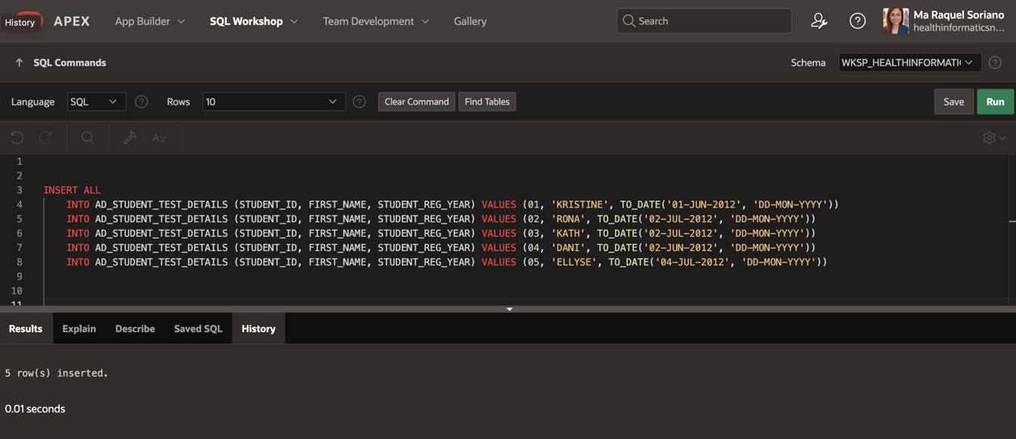

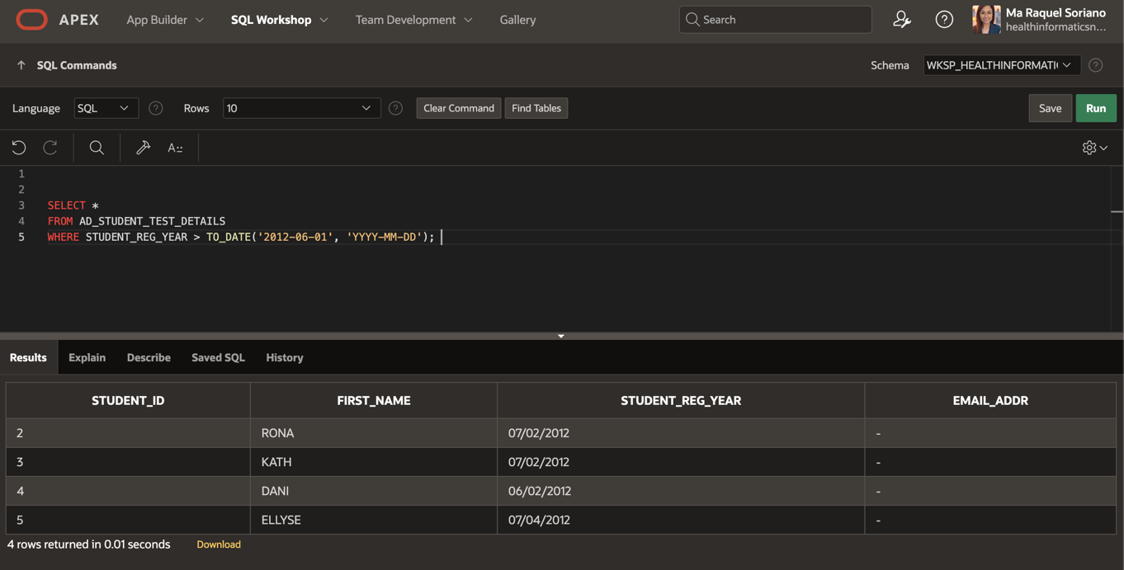

Task 5: Display the course details for departments 10 and 30.

I cannot accomplish Task 5 because there are no course details in the DEPARTMENT table.

Task 6: Display the details of students whose first name begins with the letter "J".

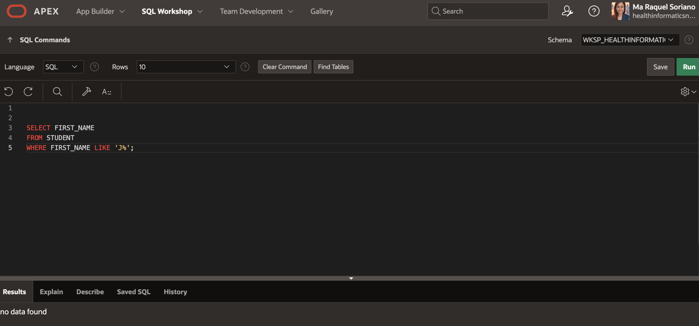

Task 7: Display the details of students who have opted for courses 190 or 193.

I encountered an error message, and I couldn’t resolve the issue. I’m not sure if it’s due to non-existent courses 190-193.

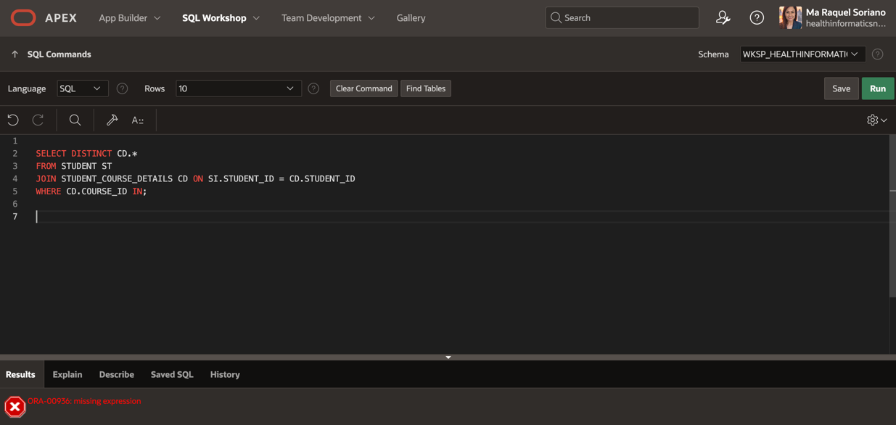

Task 8, 9, 10:

Unable to accomplish this task. Attempted to insert values for a table to come up with SQL queries for this task. Like in other previous tasks, I kept getting error messages.